Week-2
- a) Create and attach an EBS volume to an EC2 instance, and
- scale the instance by increasing CPU and RAM by changing the instance type.
2.Attach and permanently mount an EBS volume to a Linux EC2 instance to ensure data persistence across reboots.
3. Create a snapshot of the attached EBS volume and use it to create and attach a new volume to an EC2 instance in another AWS region.

- a) Create and attach an EBS volume to an EC2 instance, and
- scale the instance by increasing CPU and RAM by changing the instance type.

- Creating and attaching an EBS volume to an EC2 instance
Step 1: Create a New EBS Volume
Open the EC2 Dashboard.
From the left-hand menu, select Volumes under Elastic Block Store (EBS).
Click Create Volume.
Choose:
Volume type (gp3/gp2)
Size of the volume
Availability Zone (must be the same as the EC2 instance)
Click Create Volume.
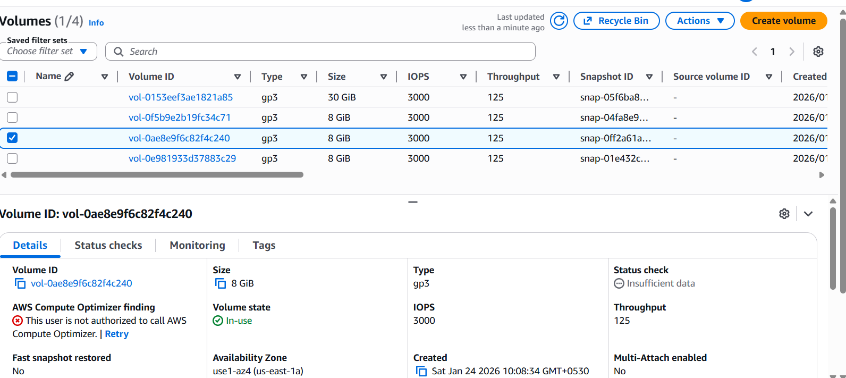
Above Picture Volume is created Automatically when an EC2 Instance is created
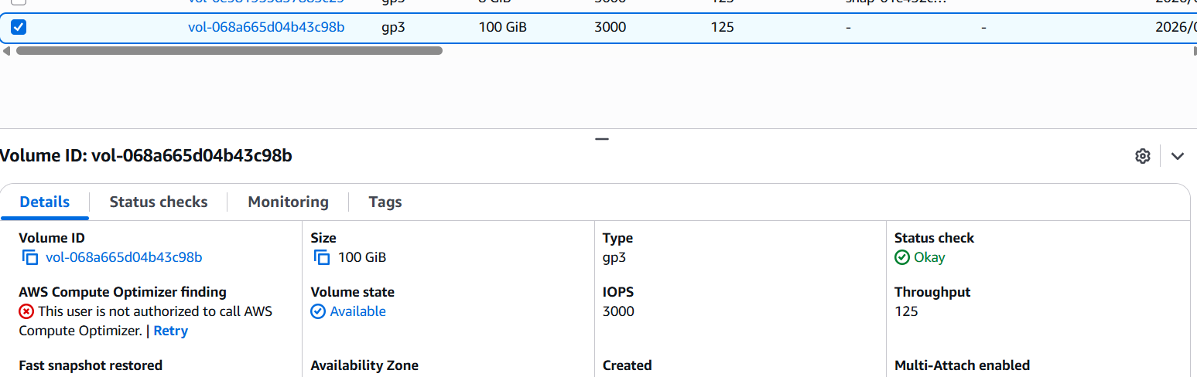
Above Picture is when we manually add EBS to EC2 Instance

Step 2: Attach the EBS Volume to the Existing EC2 Instance
In the Volumes section, select the newly created volume.
Click Actions → Attach Volume.
Select the target EC2 instance from the list.
Specify the device name (example: /dev/xvdf).
Click Attach.
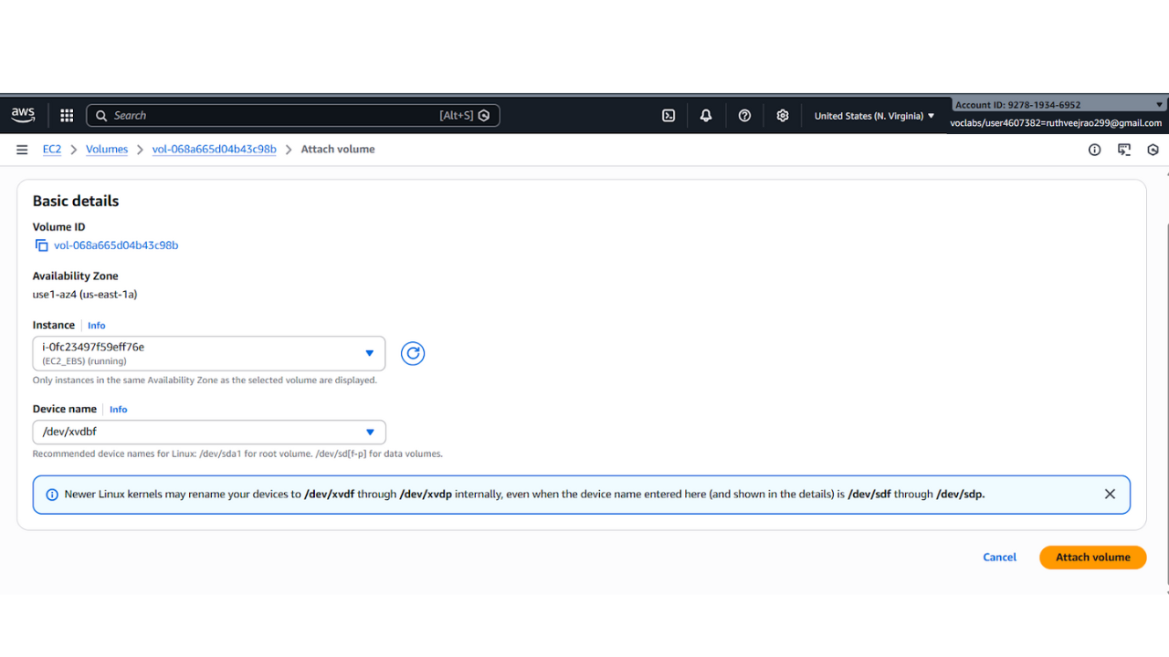

Step 3: Verify the Volume on the EC2 Instance
Connect to the EC2 instance using SSH.
Check the attached disks:
lsblk
Identify the new volume (e.g., /dev/xvdf).
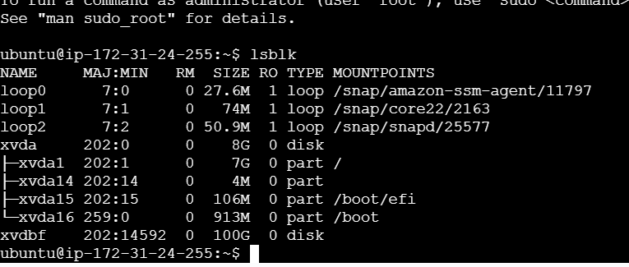

Note: Ensure that the EBS volume and the EC2 instance belong to the same Availability Zone, as cross-AZ attachment is not supported.

b)Procedure: increasing/decreasing of CPU and RAM
Step 1. - Navigate to the EC2 dashboard.
Step 2. - Stop the EC2 instance associated with the EBS volume.
Step 3. - Click "Actions" and then—instance settings—change the instance type"Modify Volume".
Step 4. -Increase/ decrease the size or change the volume type to a higher performance specification.
Step 5. - Click "Modify" to apply the changes.
Step 6: Now the start the machine you see with increase /decrease of size and performance
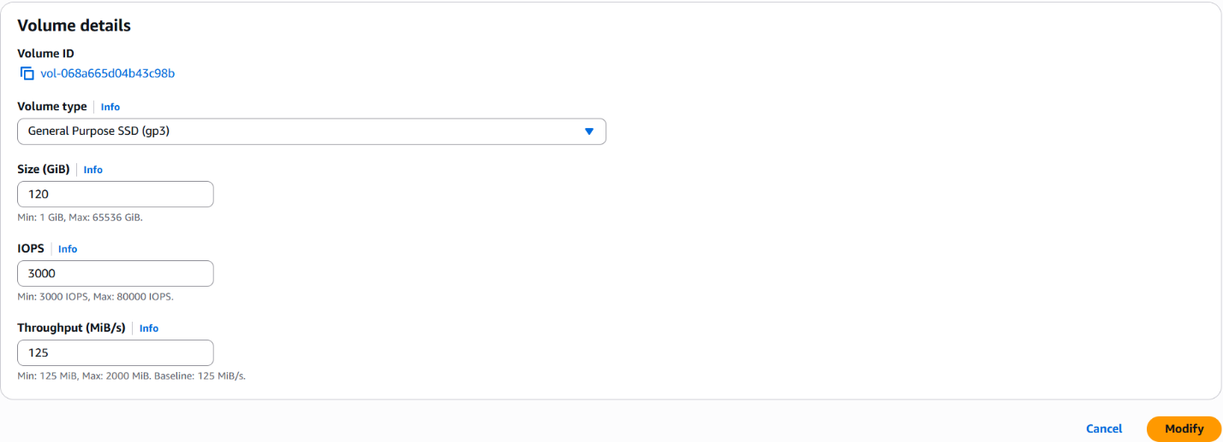
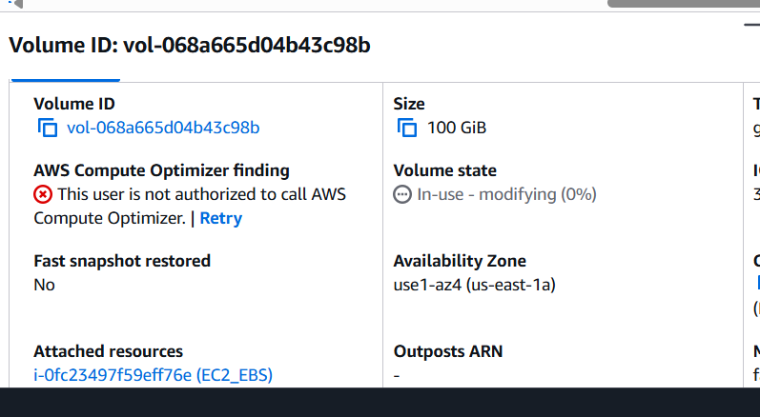
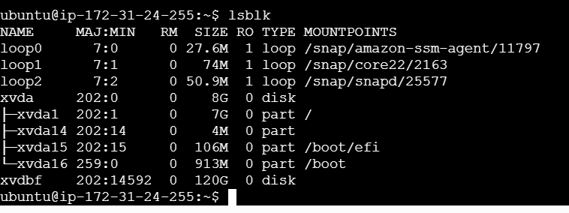

2.Attach and permanently mount an EBS volume to a Linux EC2 instance to ensure data persistence across reboots.
Step 1: Create an EBS Volume
- Log in to AWS Management Console
- Go to EC2 → Volumes
- Click Create Volume
- Choose:
  - Volume Type: gp3 (recommended)
  - Size: (e.g., 20 GB)
  - Availability Zone: Same AZ as EC2 instance
- Click Create Volume

Step 2: Attach the EBS Volume to EC2
- Select the newly created EBS volume
- Click Actions → Attach Volume
- Choose:
  - Instance: Select your Linux EC2 instance
  - Device name: /dev/xvdf
- Click Attach


Step 3: Connect to the EC2 Instance
Connect using SSH:
ssh -i key.pem ec2-user@<public-ip>
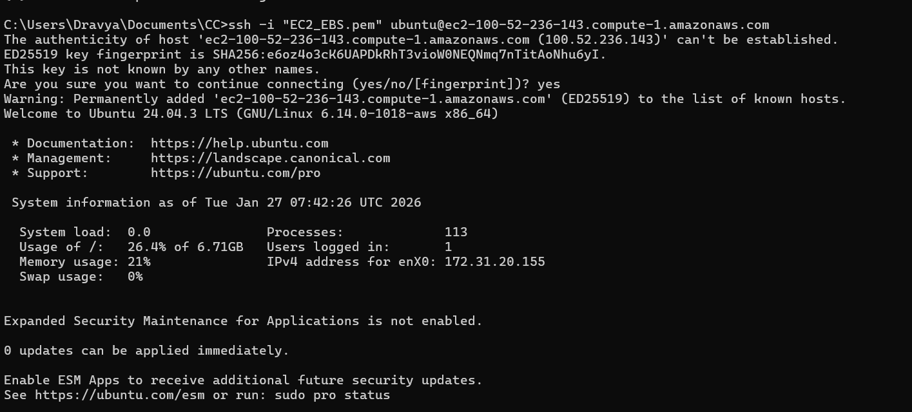

Step 4: Verify the Attached Disk
Check all available disks:
lsblk
You will see:
- Root volume: /dev/xvda
- New volume: /dev/xvdf (no partition yet)
Check filesystem:
lsblk -fs
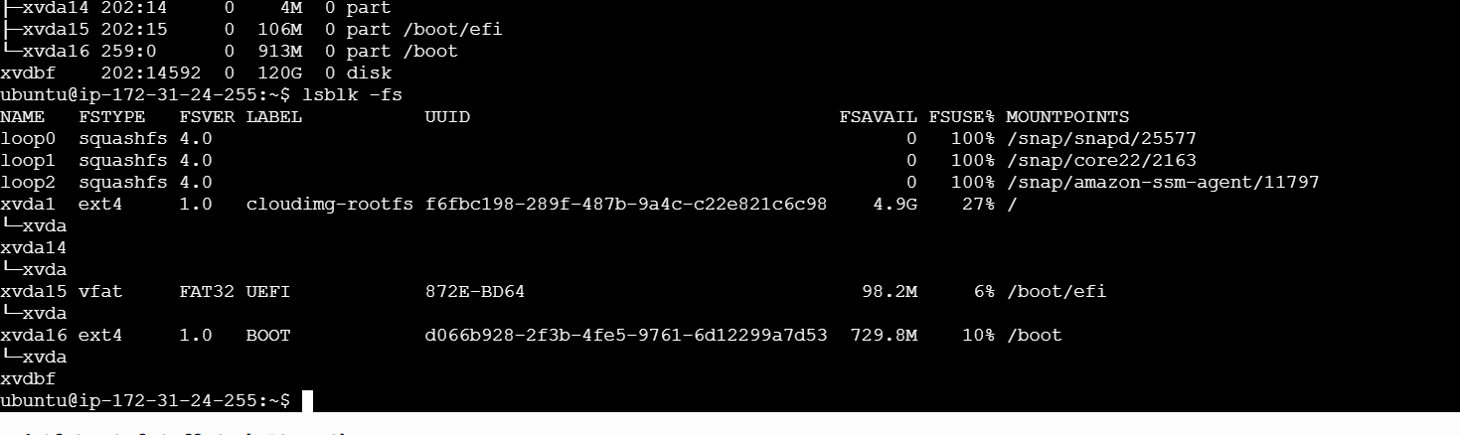

Step 5: Create a Partition
Create a partition on the new volume:
Command: sudo fdisk machine_name
fdisk /dev/xvdf
Inside fdisk:
- Press m → Help menu
- Press n → New partition
- Press p → Primary partition
- Press Enter → Default partition number
- Press Enter → Default first sector
- Press Enter → Default last sector (use full disk)
- Press w → Write changes and exit
Notify kernel:
Partprobe
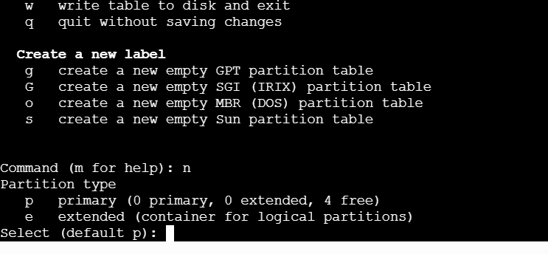
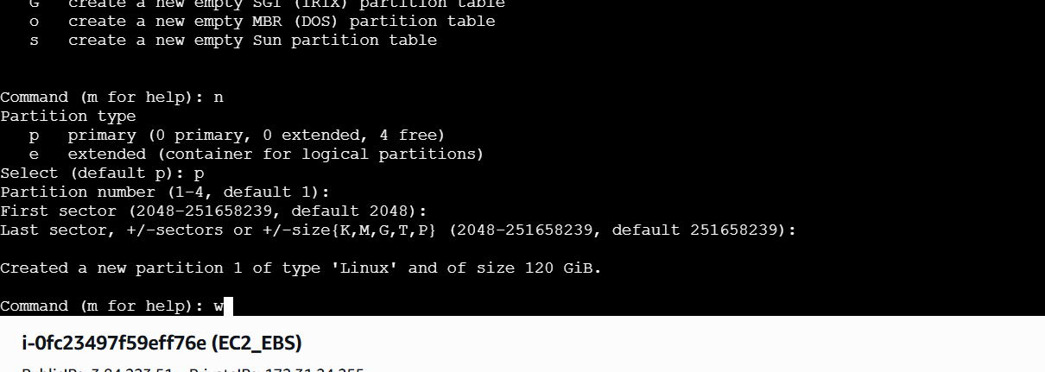

Step 6: Verify the New Partition
lsblk -fs
You should now see:
/dev/xvdf1
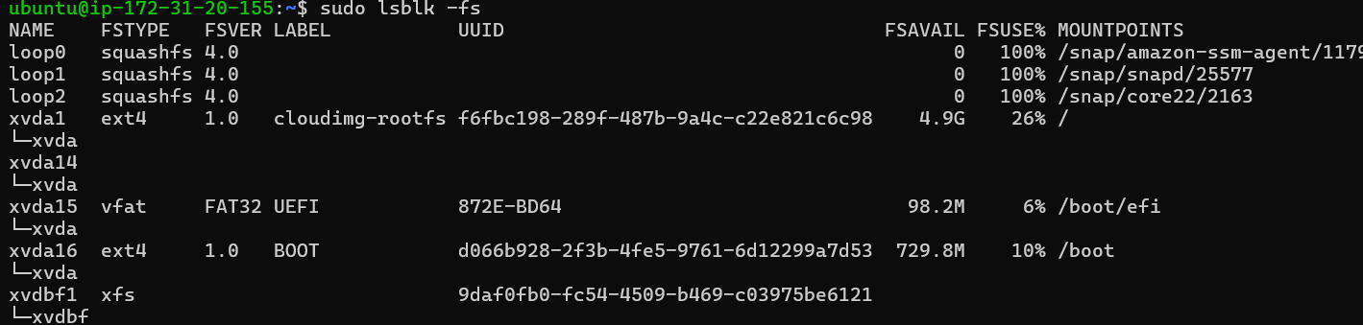

Step 7: Format the Partition
Format with XFS filesystem:
mkfs.xfs /dev/xvdf1
Verify:
lsblk -fs
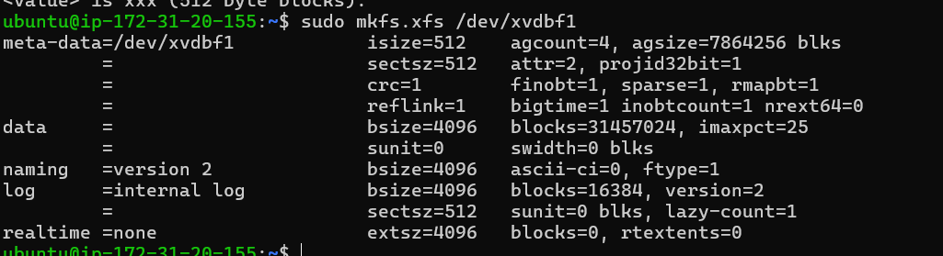


Step 8: Create a Mount Directory
mkdir /mnt/archana
Step 9: Mount the Volume
mount /dev/xvdf1 /mnt/archana
Verify:
df -h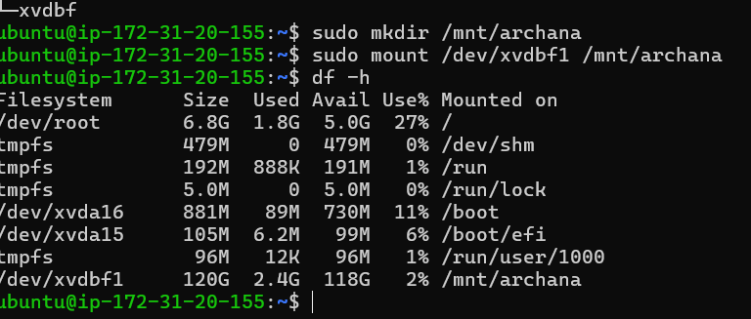

Step 10: Make the Mount Persistent
Get the UUID of the volume:
blkid /dev/xvdf1
Edit fstab:
nano /etc/fstab
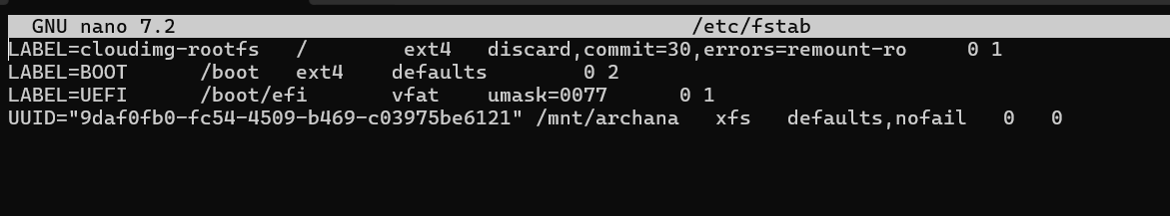
Add this line at the end:
UUID=<UUID-value> /mnt/archana xfs defaults,nofail 0 0
Save and exit.
Test fstab:
mount -a
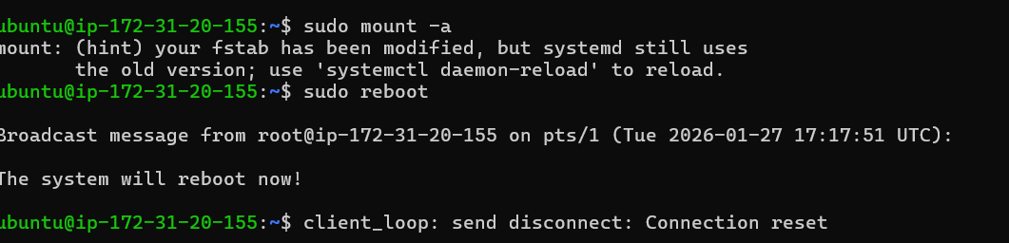

Step 11: Verify Persistence
- Reboot the instance:
Reboot
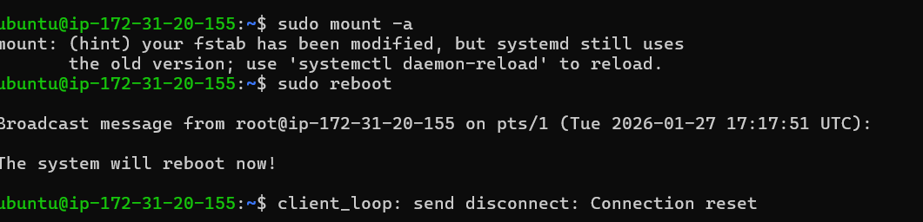
- Reconnect and check:
df -h
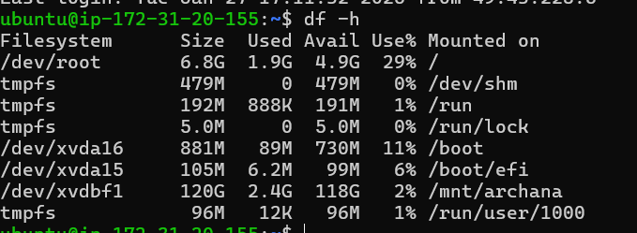
➡️ Volume should be mounted automatically.
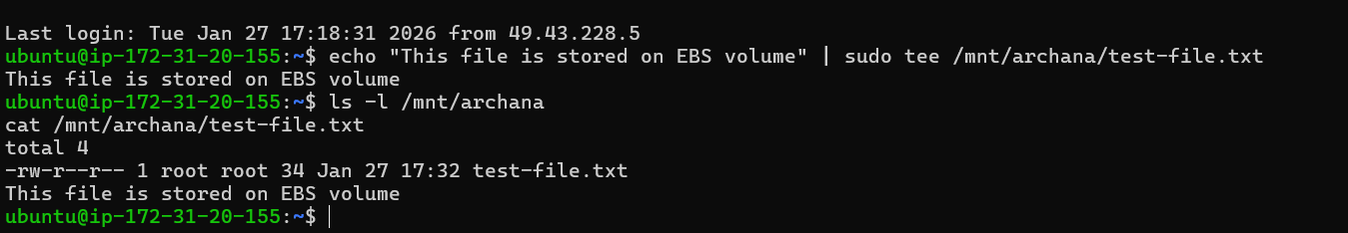

Step 12: Detach and Reattach Volume (Data Recovery Scenario)
Detach:
- EC2 → Volumes → Select volume
- Actions → Detach volume
Attach to another EC2 instance:
- Attach to new instance (same AZ)
- Login to new instance
- Create mount directory:
mkdir /mnt/archana
- Mount the volume:
mount /dev/xvdf1 /mnt/archana
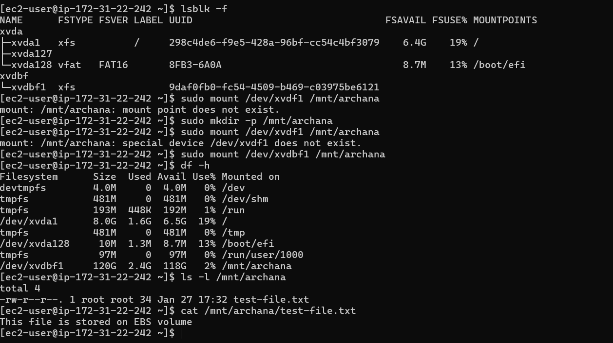
All previous data will be available

Summary Flow
Create Volume → Attach → lsblk → fdisk → mkfs → mkdir → mount → fstab → reboot

3. Create a snapshot of the attached EBS volume and use it to create and attach a new volume to an EC2 instance in another AWS region.
Attaching Volumes across regions of EC2 using the snapshot
To create a snapshot of an EBS volume and attach it to an instance in another region in AWS, you'll need to follow these steps:

Step 1. Create a Snapshot:
a. Sign in to the AWS Management Console.
b. Navigate to the EC2 Dashboard.
c. Click on "Volumes" in the left-hand navigation pane.
d. Select the EBS volume you want to create a snapshot of.
e. Click on the "Actions" dropdown menu above the volume list and select "Create Snapshot."
f. Provide a name and description for the snapshot.
g. Click on the "Create Snapshot" button to initiate the snapshot creation process.
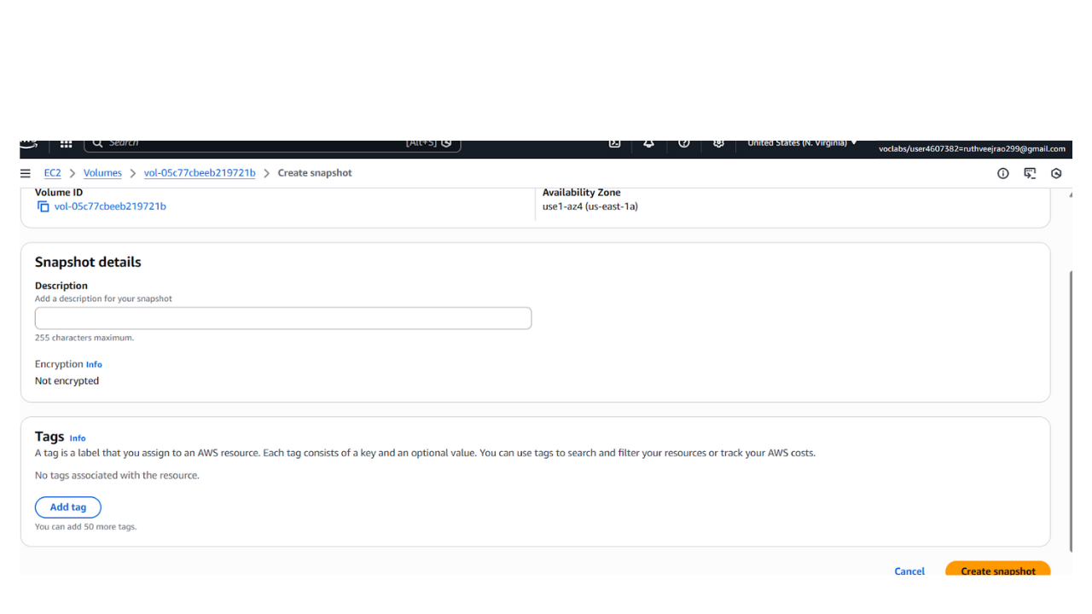

Step 2. Copy the Snapshot to Another Region:
a. Once the snapshot is created, go to the "Snapshots" section in the EC2 Dashboard.
b. Select the snapshot you just created.
c. Click on the "Actions" dropdown menu above the snapshot list and select "Copy Snapshot."
d. Choose the destination region where you want to copy the snapshot.
e. Click on the "Copy Snapshot" button to initiate the copy process. This may take some time depending on the size of the snapshot and the network speed.

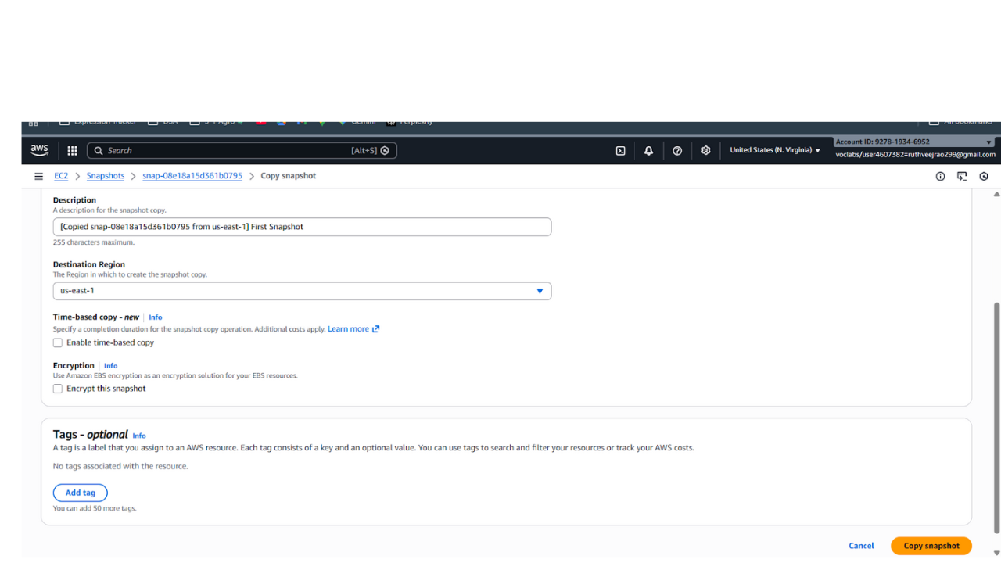
Step 3. Monitor the Snapshot Copy Progress:
a. You can monitor the progress of the snapshot copy by navigating to the "Snapshots" section in the EC2 Dashboard of the source region.
b. Look for the snapshot you copied and check its status. It will change from "pending" to "completed" once the copy process is finished.
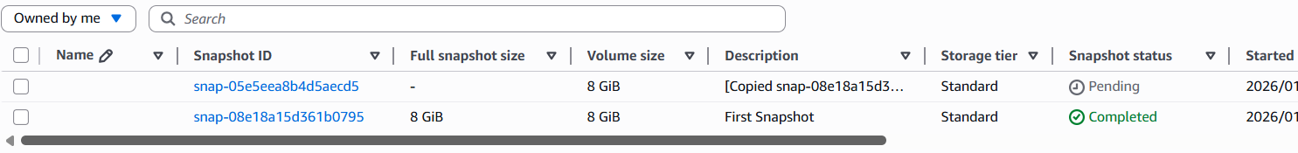
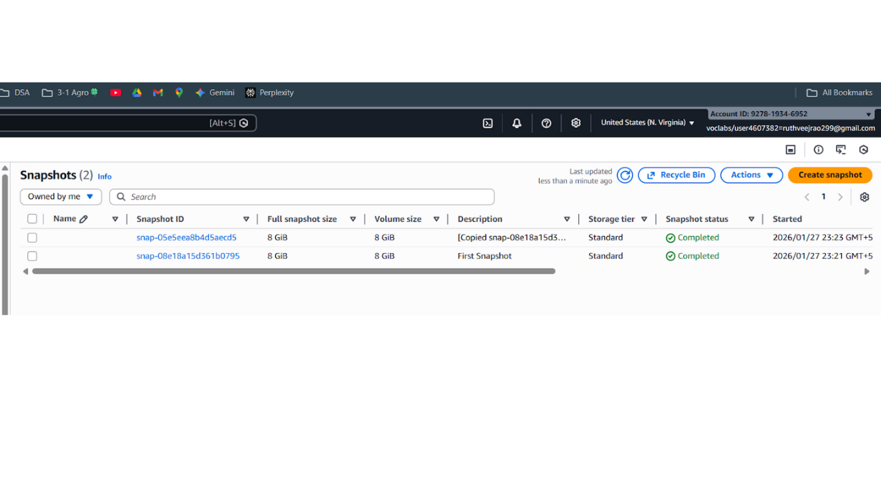
Step 4. Switch to the Destination Region:
- Use the region selector in the top-right corner of the AWS Management Console to switch to the destination region where you copied the snapshot.

Step 5. Create a Volume from the Snapshot:
a. In the EC2 Dashboard of the destination region, go to the "Snapshots" section.
b. Find the snapshot you copied from the source region.
c. Click on the snapshot, then click on the "Actions" dropdown menu and select "Create Volume."
d. Configure the volume settings, such as volume type, size, and availability zone.
e. Click on the "Create Volume" button to create the volume from the snapshot.
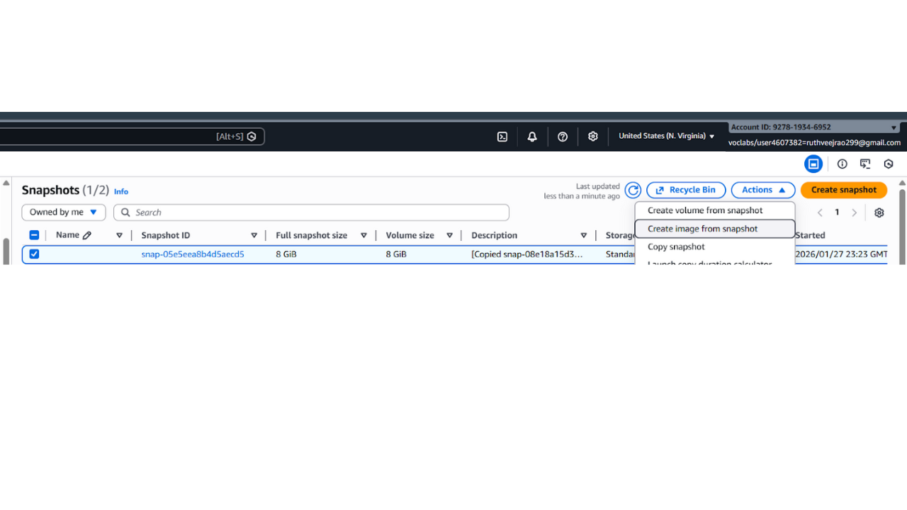
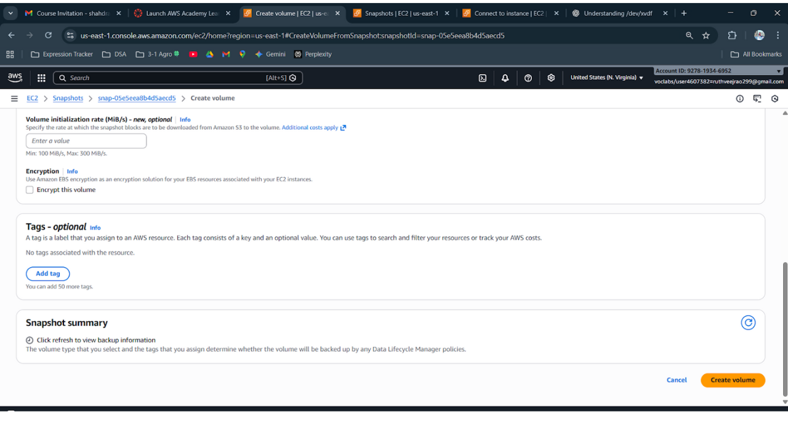

Step 6. Create the ec2 instance & Attach the Volume to an Instance:
a. Once the volume is created, navigate to the "Volumes" section in the EC2 Dashboard.
b. Find the newly created volume and select it.
c. Click on the "Actions" dropdown menu and select "Attach Volume."
D the EC2 instance to which you want to attach the volume and specify the device name.
e. Click on the "Attach" button to attach the volume to the instance.
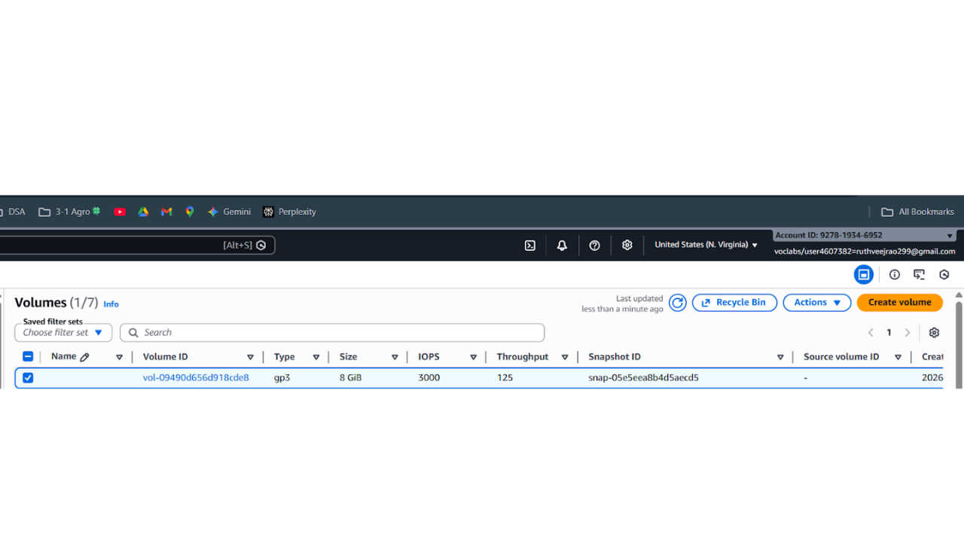
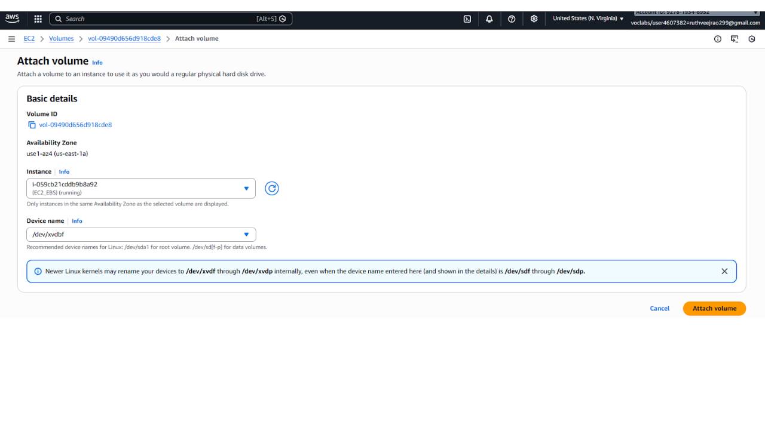
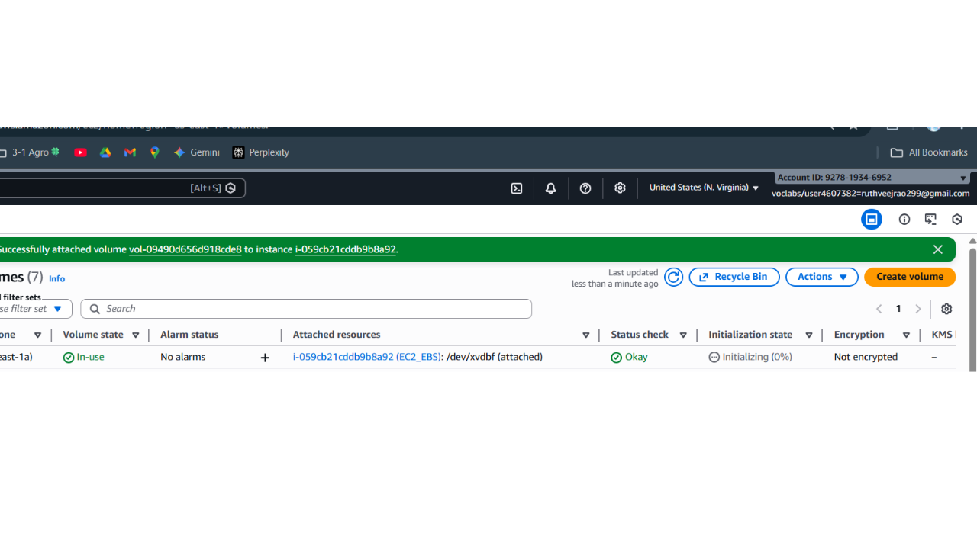

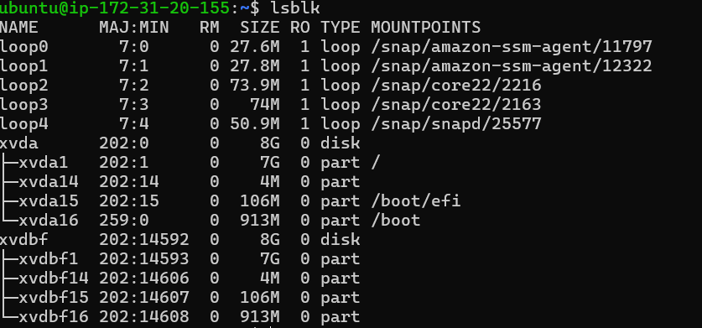
We have created a snapshot of an EBS volume, copied it to another region, created a volume from the snapshot, and attached it to an instance in the destination region.

VIVA
1. Your database server crashed. Data must be recovered fast. What do you do?
I restore the database from the latest backup or EBS snapshot.
If it’s an RDS database, I use Point-in-Time Recovery to restore it to the last working state.

2. EC2 instance is deleted accidentally. How do you recover the data?
If the EBS volumes were backed up, I create new volumes from the snapshots.
Then I attach them to a new EC2 instance to recover the data.

3. Root volume is deleted along with EC2. How do you prevent this next time?
I disable Delete on Termination for the root EBS volume.
This ensures the root volume is preserved even if the EC2 is terminated.

4. Disk is full on a production EC2 instance. What will you do?
First, I check disk usage using df -h and clean unnecessary logs or temp files.
If needed, I increase the EBS volume size and extend the filesystem.

5. You want to migrate an EC2 instance to another AWS region. How will you do it?
I create an EBS snapshot of the instance and copy it to the target region.
Then I create a new volume and launch a new EC2 instance there.

6. What happens to EBS when an EC2 instance is stopped?
Nothing happens to the EBS volume.
It remains attached to the instance and all data is preserved.

7. What happens to EBS when an EC2 instance is terminated?
The root volume is deleted by default.
Any additional EBS volumes remain unless explicitly set to delete.

8. Application requires 20,000 IOPS. Which EBS volume will you choose?
I will choose Provisioned IOPS SSD (io2).
It is designed for high-performance and mission-critical workloads.

9. Can one EBS volume be attached to multiple EC2 instances?
No, except for io1/io2 volumes with Multi-Attach enabled.
This is mainly used for clustered applications.

10. You deleted an EBS volume by mistake. How can you recover it?
A deleted EBS volume cannot be recovered directly.
The only way is to restore it from an existing snapshot.

11. What happens if a snapshot used by a volume is deleted?
The volume continues to work normally.
AWS internally keeps the required snapshot blocks.

12. Where are EBS snapshots stored?
EBS snapshots are stored in Amazon S3, managed by AWS.
They are highly durable, secure, and region-specific.

✅ PART 1

Create & Attach an EBS Volume to EC2

Then Scale CPU & RAM (Change Instance Type)

🟢 STEP 0 — What You Must Already Have
You must already have:
✔ A running Linux EC2 instance
✔ SSH access working
✔ Know your region (example: ap-south-1)

🟢 STEP 1 — Create a New EBS Volume
- Login to AWS
- Go to EC2
- On left side click:
Elastic Block Store → Volumes
- Click:
Create Volume
Now fill carefully:

Volume Type:
gp3

Size:
Example:
10 GiB

Availability Zone:
⚠️ VERY IMPORTANT
It MUST match your EC2 instance AZ.
How to check AZ:
- Go to EC2 → Instances
- Click your instance
- See:
Availability Zone: ap-south-1a
Now select SAME AZ while creating volume.
Click:
Create Volume

📝 WRITE THIS DOWN
- Volume ID (example: vol-0abc123)
- Availability Zone
- Size

🟢 STEP 2 — Attach Volume to EC2
- Stay in Volumes
- Select your new volume
- Click:
Actions → Attach Volume
- Choose:
Instance → Select your EC2
Device Name → /dev/xvdf
Click:
Attach

🟢 STEP 3 — Verify Inside EC2
Now connect via SSH:
ssh -i key.pem ubuntu@<public-ip>
Now check disks:
lsblk
You will see something like:
xvda (root disk)
xvdf (new disk)
📌 COMMAND USED:
lsblk
Purpose: List block devices

🟢 PART B — SCALE CPU & RAM (Change Instance Type)
⚠️ IMPORTANT:
You CANNOT change instance type while running.

STEP 1 — Stop Instance
Go to:
EC2 → Instances
Select instance
Click:
Instance state → Stop instance
Wait until:
Stopped

STEP 2 — Change Instance Type
Click:
Actions → Instance Settings → Change Instance Type
Select bigger one:
Example:
From:
t2.micro (1 vCPU, 1 GB RAM)
To:
t2.small (1 vCPU, 2 GB RAM)
or
t2.medium (2 vCPU, 4 GB RAM)
Click:
Apply

STEP 3 — Start Instance
Click:
Instance state → Start instance

STEP 4 — Verify New CPU/RAM
SSH again.
Run:
lscpu
Shows CPU info.
Run:
free -h
Shows RAM.
📌 COMMANDS USED:
lscpu
free -h

✅ PART 2

Permanently Mount EBS Volume (So It Survives Reboot)
Now we prepare disk properly.

STEP 1 — Check Disk
lsblk
You’ll see:
xvdf
No partition yet.

STEP 2 — Create Partition
Command:
sudo fdisk /dev/xvdf
Inside fdisk press:
n (new partition)
p (primary)
Enter
Enter
Enter
w (write)
Then:
sudo partprobe
Now check:
lsblk
You should see:
xvdf1

STEP 3 — Format Disk
We format using XFS.
sudo mkfs.xfs /dev/xvdf1
COMMAND USED:
mkfs.xfs
Purpose: Create filesystem

STEP 4 — Create Mount Folder
sudo mkdir /mnt/mydata

STEP 5 — Mount It
sudo mount /dev/xvdf1 /mnt/mydata
Check:
df -h

STEP 6 — Make Permanent (VERY IMPORTANT)
Get UUID:
sudo blkid
You’ll see something like:
UUID="abcd-1234"
Copy UUID.

Edit fstab:
sudo nano /etc/fstab
Add this line:
UUID=abcd-1234 /mnt/mydata xfs defaults,nofail 0 0
Save:
CTRL + X
Y
Enter
Test:
sudo mount -a

STEP 7 — Reboot Test
sudo reboot
Reconnect and check:
df -h
If mounted → SUCCESS 🎉

📋 ALL COMMANDS USED IN PART 2
lsblk
sudo fdisk /dev/xvdf
sudo partprobe
sudo mkfs.xfs /dev/xvdf1
sudo mkdir /mnt/mydata
sudo mount /dev/xvdf1 /mnt/mydata
df -h
sudo blkid
sudo nano /etc/fstab
sudo mount -a
sudo reboot

✅ PART 3

Snapshot → Copy to Another Region → Create Volume → Attach

STEP 1 — Create Snapshot
Go to:
EC2 → Volumes
Select volume
Click:
Actions → Create Snapshot
Give name:
mydata-snapshot
Click Create.

STEP 2 — Copy Snapshot to Another Region
Go to:
EC2 → Snapshots
Select snapshot
Click:
Actions → Copy Snapshot
Choose:
Destination Region
Click Copy.
Wait until status:
Completed

STEP 3 — Switch Region
Top right corner → Change region.

STEP 4 — Create Volume from Snapshot
Go to:
EC2 → Snapshots
Select copied snapshot
Click:
Actions → Create Volume
Choose:
- Same AZ as target instance
Click:
Create Volume

STEP 5 — Attach to Instance
Volumes → Select volume
Click:
Actions → Attach Volume
Choose instance.

STEP 6 — Mount in New Region Instance
SSH into that instance.
Run:
lsblk
If partition exists:
sudo mkdir /mnt/mydata
sudo mount /dev/xvdf1 /mnt/mydata
Data will be there 🎉

🧠 WHAT TO TRACK CAREFULLY
Always write down:
- Region
- Availability Zone
- Volume ID
- Snapshot ID
- Instance ID
- Mount directory name
- UUID

